
CHUKA UNIVERSITY

FACULTY OF SCIENCE AND TECHNOLOGY
DEPARTMENT OF COMPUTER SCIENCE
Title: Design and Implementation of AI-powered GraphRAG assistant organizing and retrieving Chuka University’s open data and academic materials
Name: Dancun Mau Wainaina
Registration Number: EB1/61516/22
Degree: Bachelor of Science in Computer Science
Course Code: COSC 482
Course Name: Computer Systems Project 1
Project Coordinator: Dr Benard Osero

Submitted in partial fulfillment of the requirements for the award of the degree
Date: December 2025

TABLE OF CONTENTS
Section | Page
COVER PAGE | i
TABLE OF CONTENTS | ii
LIST OF TABLES | iv
LIST OF FIGURES | v
CHAPTER 1: INTRODUCTION
1.0 Introduction | 5
1.1 Background to the Study | 6
1.2 Problem Statement | 3
1.3 Proposed Solution | 4
1.3.1 Aim of the Project | 5
1.3.2 Objectives | 5
1.4 Significance of Project | 6
1.5 Expected Outcomes/Deliverables | 7
1.6 Keywords | 7
CHAPTER 2: LITERATURE REVIEW
2.1 Knowledge Graphs in Education | 8
2.2 Retrieval-Augmented Generation (RAG) | 9
2.3 GraphRAG Systems | 10
2.4 Educational Chatbots and Assistants | 11
2.5 Research Gap | 12
CHAPTER 3: METHODOLOGY
3.1 Research Design | 13
3.2 System Development Approach | 13
3.3 Data Collection Methods | 14
3.4 Technology Stack | 15
3.5 Development Phases | 16
CHAPTER 4: SYSTEM INVESTIGATION, ANALYSIS AND REQUIREMENTS DEFINITION
4.1 Introduction | 17
4.2 Current System/Environment | 17
4.3 Gaps/Shortcomings in Current System | 18
4.4 The Intended System | 19
4.5 Functional Requirements | 20
4.6 Non-Functional Requirements | 21
CHAPTER 5: SYSTEM DESIGN
5.1 Introduction | 22
5.2 System Architecture Design | 23
5.3 Process Flow Design | 24
5.4 Database Design | 25
5.5 Interface Design | 27
5.6 Security Design | 28
APPENDICES | 29
Appendix A: Resources Required/Budget | 29
Appendix B: Time Plan (Gantt Chart) | 30
Appendix C: Sample Queries and Responses | 31
REFERENCES | 32

LIST OF TABLES
Table No. | Title | Page
Table 3.1 | Technology Stack Components | 15
Table 4.2 | Functional Requirements | 20
Table 4.3 | Non-Functional Requirements | 21
Table 5.1 | Database Schema - Students Table | 25
Table 5.2 | Neo4j Node Types and Properties | 26
Table A.1 | Project Budget Breakdown | 29
Table B.1 | Project Timeline and Milestones | 30

LIST OF FIGURES
Figure No. | Title | Page
Figure 3.1 | System Development Methodology | 14
Figure 5.1 | System Architecture Diagram | 23
Figure 5.2 | GraphRAG Pipeline Flowchart | 24
Figure 5.3 | Knowledge Graph Schema | 26
Figure 5.4 | User Interface Wireframes | 27
Figure 5.5 | Authentication Flow Diagram | 28
Figure B.1 | Project Gantt Chart | 30

CHAPTER 1: INTRODUCTION
1.0 Introduction
In the contemporary higher education landscape, universities generate vast amounts of academic data including course catalogs, timetables, examination papers, fee structures, policy documents, and administrative guidelines. Efficient organization and retrieval of this information is critical for student success and institutional effectiveness. However, traditional information management systems often fail to provide intuitive, context-aware access to institutional knowledge, leading to information fragmentation and inefficient student institution interactions.
Chuka University serves over 15,000 students across multiple campuses offering diverse programs from certificate to PhD levels. The university maintains an extensive digital repository (repository.chuka.ac.ke) containing examination papers, research publications, and academic materials. Additionally, critical information exists in various formats: PDF timetables, handbooks. This distributed nature of information creates significant accessibility challenges for students who must navigate multiple platforms to obtain basic academic information such as their personalized timetable, fee payment details or past examination papers.
Recent advances in Artificial Intelligence, particularly in Knowledge Graphs and Retrieval-Augmented Generation (RAG), offer promising solutions for organizing and intelligently retrieving institutional data. Knowledge graphs provide structured representations of entities and relationships, naturally modeling academic hierarchies (Faculty > Department > Program >Course > Unit). RAG systems enhance Large Language Model (LLM) responses by grounding them in retrieved documents, reducing hallucinations and improving factual accuracy. The fusion of these technologies, GraphRAG enables context-aware information retrieval that understands both the structure of academic data and the semantic content of documents.
This project proposes the design and implementation of a GraphRAG Assistant specifically tailored for Chuka University's academic ecosystem. By integrating Neo4j graph database, FAISS vector store, and Google Gemini LLM, the system will provide students with a conversational interface to access personalized academic information. The assistant will understand queries like "What units do I take this semester?" by traversing the knowledge graph using the student's profile (program, year, semester) and generate natural language responses enriched with direct links to authoritative sources.
The system addresses a critical gap in student information services by transforming fragmented data into an intelligent, accessible knowledge base. This aligns with Chuka University's vision of providing quality education and its commitment to leveraging technology for improved service delivery.
1.1 Background to the Study
Higher education institutions worldwide are experiencing a digital transformation driven by the need to improve information accessibility and student experience. Traditional methods of information dissemination through notice boards, printed documents, and static websites are increasingly inadequate for meeting the expectations of digitally native students who demand instant, personalized access to information. At Chuka University, academic information exists in various formats and locations. Timetables are distributed as Word documents or PDF files, often requiring students to manually search through lengthy documents to find their specific class schedules. Past examination papers are stored in the university repository (repository.chuka.ac.ke) but lack intelligent search capabilities, forcing students to browse through numerous items to find relevant materials. Fee structures vary by program, study mode, and campus, creating confusion among students trying to understand their financial obligations. University services information is scattered across different sources.
Recent advances in artificial intelligence, particularly in natural language processing and knowledge representation, present an opportunity to address these challenges. GraphRAG represents a cutting-edge approach that combines the structured representation capabilities of knowledge graphs with the semantic understanding of large language models and the retrieval precision of vector databases. This hybrid architecture enables systems to understand complex relationships between academic entities while providing natural language interfaces for information access.
Knowledge graphs excel at representing interconnected academic data courses relate to departments, semesters include specific units and examination papers correspond to particular courses. Vector databases enable semantic search, allowing students to find relevant information even when their queries don't exactly match the stored content. Large language models provide natural language understanding and generation, enabling conversational interactions that feel intuitive and human-like.
The GraphRAG approach has been successfully implemented in various domains including enterprise knowledge management, customer service, and healthcare information systems. However, its application to university academic information management, particularly in the Kenyan context, remains largely unexplored. This project seeks to address this gap by developing a context-aware, institution-specific assistant tailored to Chuka University's unique academic structure and student needs. The emergence of Large Language Models (LLMs) like GPT-4, Gemini, and Claude has revolutionized natural language interfaces. However, raw LLMs suffer from hallucination and lack access to institution specific data. Retrieval-Augmented Generation (RAG) addresses these limitations by retrieving relevant documents before generation, grounding responses in factual sources.
Knowledge graphs are increasingly effective in education technology, especially for organizing complex academic information. Microsoft Research’s 2024 introduction of GraphRAG showed major improvements over traditional RAG by combining document retrieval with community detection on knowledge graphs. This approach captures both local context and global relationships, making it ideal for university systems where hierarchical structures (Programme >Course > Unit) and temporal patterns (Semester schedules) must be understood accurately.
1.2 Problem Statement
Students at Chuka University face significant challenges in accessing and navigating academic information, resulting in time wastage. A preliminary survey conducted with five students across different programs revealed consistent patterns of information access difficulties.
The primary challenges identified include:
1. Fragmented Information Sources- Academic information is distributed across multiple disconnected sources. Timetables exist as Word documents distributed through WhatsApp groups. Examination papers are stored in the university repository but require manual navigation through thousands of items. University services information exists in the 82-page student handbook, making specific information difficult to locate quickly. This fragmentation forces students to consult multiple sources for routine academic queries, consuming valuable time that could be dedicated to academic pursuits.
2. Lack of Personalization -Current information systems do not account for individual student contexts. A Computer Science student receives the same generic timetable document as all other students, requiring them to manually identify their specific class schedule from a comprehensive timetable containing hundreds of entries for all programs.
3. Time-Consuming Manual Search Survey respondents reported spending an average of 15-20 minutes daily searching for basic academic information. Finding relevant past examination papers requires browsing through the repository. Verifying class schedules involves manually referencing information across timetable documents, making the process slow and inefficient. Locating specific university services or contact information necessitates searching through the entire student handbook.
4. Limited Accessibility Current systems do not support natural language queries or conversational interactions. Students cannot ask questions like "What classes do I have on Monday?" or "Find exam papers for Database Systems." Information access requires knowledge of specific document locations and navigation procedures.
5. Curriculum Information Gaps Students struggle to access comprehensive information about course structures and unit offerings. Understanding which units will be offered in future semesters is difficult.
6. Administrative Burden-Class representatives are overburdened with forwarding information

1.3 Proposed Solution
1.3.1 Aim of the Project
The aim of this project is to design and implement an AI-powered GraphRAG Assistant that organizes Chuka University's fragmented academic information into a unified, intelligent knowledge base and provides students with personalized, context-aware access to academic materials through natural language conversational interface.
1.3.2 Objectives
The specific objectives of this project are:
- To analyze the current state of academic information management at Chuka University and identify gaps, inefficiencies, and user pain points through stakeholder surveys and system observation.
- To design a knowledge graph schema that accurately models Chuka University's academic structure including faculties, departments, programs, courses, units, timetables, examination papers, and their inter-relationships.
- To develop data extraction pipelines that parse and transform academic data from multiple formats into structured representations suitable for graph database and vector store ingestion.
- To implement a hybrid retrieval system that combines Neo4j graph traversal for structured, relationship-based queries with FAISS vector similarity search for semantic document retrieval, enhanced by intelligent query routing based on intent classification.
- To integrate Google Gemini LLM for natural language query understanding, entity extraction, and response synthesis that generates accurate, grounded answers citing authoritative sources.
- To build personalized web application using Streamlit that authenticates students, and provides conversational interface for information retrieval with features including personalized timetable generation and direct repository linking.
1.4 Significance of Project
1. Benefits to Students-Primary Beneficiaries: The 15,000+ students across undergraduate, postgraduate, certificate, and diploma programs will gain:
- Time Efficiency: Reducing information search time from hours to seconds, freeing time for academic focus.
2. Benefits to University Administration-Departments and administrative offices will experience reduced Query Volume and identification of information gaps in current documentation.
3. Student Researcher Development-The project provides the student researcher with advanced technical Skills, domain expertise, research methodology.
1.5 Expected Outcomes/Deliverables
- Functional GraphRAG Assistant Web Application
- Streamlit application accessible via web browser
- User authentication system
- Conversational query interface
- Responsive design
- Documented and reusable for future semester updates
2.Improved Student Information Access
3.Institutional Knowledge Base.
1.6 Keywords
Graph Retrieval-Augmented Generation (GraphRAG), Knowledge Graph, Semantic Search, Neo4j, FAISS, Large Language Model (LLM), Google Gemini, Information Retrieval, Natural Language Processing, Vector Embeddings, Sentence Transformers, Personalization, Conversational AI, Student Information System, Chuka University, Hybrid Retrieval, Streamlit, PostgreSQL, Python, Data Integration, Cypher Query Language, Entity-Relationship Modeling, RAG Architecture.

CHAPTER 2: LITERATURE REVIEW
Knowledge graphs represent entities and relationships in structured formats enabling semantic reasoning. Singhal (2012) introduced Google's Knowledge Graph, demonstrating how structured relationships enhance search beyond keyword matching. MIT's Course Catalog Graph (2019) reduced advising appointments by 25% by modeling prerequisites and course sequences. Neo4j has emerged as the leading graph database for education demonstrating 10-100x performance improvements over relational databases for academic hierarchy queries. However, existing educational knowledge graphs focus on course recommendations and prerequisites, not operational data like timetables, examinations, and fees the fragmentation challenge at Chuka University where information spans repository.chuka.ac.ke, PDF timetables, and handbooks.
2.1 Retrieval-Augmented Generation (RAG)
Lewis et al. (2020) introduced RAG, combining document retrieval with language generation and reducing hallucinations by up to 60% compared to generation only models.
Recent RAG studies highlight key challenges in educational contexts, including document diversity, temporal sensitivity as academic content changes, and the need for personalization where profile-aware retrieval shows substantial relevance gains. These issues mirror Chuka University’s environment, where semester timetables shift and students require program- and year-specific information.
However, standard RAG still struggles with multi-hop reasoning: answering “What units do I take?” requires traversing student > program > year > semester > units relationships rather than relying solely on document retrieval.
2.2 GraphRAG Systems
GraphRAG merges knowledge graphs' structural reasoning with RAG's document grounding. Microsoft's GraphRAG (Edge et al., 2024) achieved 20-30% improvement over baseline RAG on complex multi-hop questions. Educational applications include CourseGraph-RAG (Wu et al., 2023) at University of Illinois with 89% advisor approval.
No published work addresses GraphRAG for comprehensive university systems integrating curriculum, operations, and policies the gap at Chuka University where students manually navigate repositories with ~17553 exam papers, extract timetables from ~26+ page PDFs, and search 83-page handbooks. African implementations face unique challenges. Most systems are narrow (single domain), context-unaware (no student profiles), document-only (no graph structure), and proprietary limitations impacting Chuka University's 17,000+ students across three campuses.
2.3 Research Gap
Literature review reveals critical gaps:
- Lack of Comprehensive Integration: Existing systems do not unify curriculum, timetables, examinations, fees, and institutional policies into a single intelligent retrieval system.
- No African University GraphRAG: Published work concentrates on Western universities with robust budgets. African universities need low-cost, adaptable solutions for resource-constrained multi-campus environments.
- Limited Personalization: Current chatbots lack mechanisms for student-specific context ("my timetable" requires knowing program, year, semester).
4. Disconnected Repositories: Institutional repositories like Chuka's remain isolated from
information systems.
Project Contribution:
This project addresses gaps by:
- Designing first comprehensive GraphRAG system for African university integrating Chuka University's curriculum, operations, and policies
- Implementing low-cost solution using open-source tools (Neo4j, FAISS, Gemini API)
- Enabling robust personalization using student profiles stored in PostgreSQL
- Integrating repository.chuka.ac.ke with conversational interface via direct PDF linking

CHAPTER 3: METHODOLOGY
3.1 Research Design
This project employs a Design Science Research (DSR) methodology, appropriate for developing and evaluating IT artifacts intended to solve identified organizational problems (Hevner et al., 2004). DSR consists of three iterative cycles.
- Problem Context-Chuka University students' information accessibility challenges
- Requirements-Derived from stakeholder needs analysis
- Field Testing-User acceptance testing with actual students
Design Cycle: Iterative construction and evaluation of artifacts. For this project:
- Artifacts: GraphRAG system components (knowledge graph, retrieval pipeline, web interface)
- Iterations: Prototype > Test > Refine based on evaluation results
- Design Principles: Drawn from knowledge graphs, RAG, and HCI best practices
Rigor Cycle: Grounds research in scientific knowledge base. For this project:
- Foundations: Literature on knowledge graphs, RAG, educational technology
- Methodologies: Graph database design, vector indexing, LLM prompting strategies
- Evaluation: Empirical testing against established metrics (accuracy, latency, usability)
Research Philosophy:
The project adopts a pragmatist epistemology, emphasizing practical problem-solving over purely theoretical contributions. Success is measured by system utility for actual students, not just technical novelty.
Mixed Methods Approach:
Combines quantitative and qualitative methods:
Quantitative:
- System performance metrics (query accuracy, response time)
- Usage analytics (query volume, success rates)
- Structured surveys (Likert-scale satisfaction ratings)
Qualitative:
- Stakeholder interviews (students, administrators)
- Open-ended feedback on user experience
- Observational studies of students using system
3.2 System Development Approach
The project follows an Agile development methodology adapted for academic project constraints:
Why Agile?
- Iterative Refinement: Requirements clarity emerges through prototyping; Agile accommodates evolving understanding
- Frequent Testing: Two-week sprints enable continuous validation against user needs
- Risk Mitigation: Early integration testing identifies technical issues before final phases
- Stakeholder Engagement: Regular demos to supervisor and pilot users ensure alignment
3.3 Data Collection Methods
The project requires two types of data collection: technical data (for system construction) and evaluation data (for performance assessment).
3.3.1 Technical Data Collection
Primary Data Sources:
Source 1: Timetable Data
- Document: Final_Teaching_TT_-Sept~_Dec.__2025.pdf (26 pages)
- Method: Automated PDF parsing using pdfplumber
- Output: timetable.csv with fields: day, room, time, unit code, semester
- Volume: ~2,000 timetable entries
Source 2: Program and Fee Information
- Document: CU-Advert-October-2024-F.pdf (14 pages)
- Target Data:
- Program names and codes
  - Admission requirements
  - Fees per semester
  - Duration in semesters
- Output: programs.csv with fields: code, name, level, duration, fee, department
- Volume: ~250 programs
Source 3: Course-Unit Mapping
- Document: To be provided by department (expected format: PDF or CSV)
- Target Data:
  - Course code Units per year/semester
  - Unit names
- Output: courses_units.csv
- Volume: ~13000 units across programs
Source 4: Examination Papers Metadata
- Source: repository.chuka.ac.ke
- Method: Web scraping with rate limiting.
Output: exam papers. json

Source 5: Student Handbook
Document: Student-handbook-August-2024.docx.pdf (83 pages)
Method:
1. Extract text using pdfplumber
2. Chunk
3. Generate embeddings using Sentence-BERT
4. Store in FAISS index
Output: handbook_chunks.pkl + faiss_index.bin
Volume: ~5,000 chunks
Data Validation:
Each source undergoes validation:
- Completeness: Check for missing required fields
- Consistency: Cross-reference unit codes across timetable and courses
Evaluation Data Collection
Method 1: System Performance Metrics
What: Automated logging of query processing
Metrics:
- Query response time (milliseconds)
- Retrieval accuracy (correct vs incorrect)
- Query success rate (answered vs failed)
- Collection: Python logging module storing to database
- Analysis: Descriptive statistics, distribution plots

Method 2: Test Query Evaluation
What: Curated set of 50 test queries with ground truth answers
Examples:
- What units do I take in Year 4 Semester 1?" → List of specific units
- When is COSC 482 exam?" → Specific date from exam schedule
- What's the fee per semester?" → Amount in KES
Evaluation: Manual comparison of system output vs ground truth
Metric: Accuracy = (correct answers / total queries) × 100

Method 3: User Acceptance Testing (UAT)

Sample: 20-30 volunteer students across programs and years
Method: Structured usability study
1. Task-Based Testing: Give users 10 information-seeking tasks
2. Think-Aloud Protocol: Users verbalize thought process while using system
3. Post-Test Survey: Likert-scale questions on satisfaction, ease of use, usefulness
4. Open Feedback: Qualitative comments on likes, dislikes, suggestions
Data Collection: notes

Method 4: Comparative Baseline
What: Measure current information retrieval time
Method: Ask 10 students to find information using existing methods (manual PDF search, asking peers)
Tasks: Same 10 tasks as UAT
Metrics: Time to completion, success rate
Comparison: GraphRAG system vs baseline

Ethical Considerations:
Informed Consent: Participants informed of study purpose, voluntary participation
- Data Privacy: No personally identifiable information stored
- Anonymity: Survey responses anonymous
- Right to Withdraw: Participants can exit study anytime

CHAPTER 4: SYSTEM INVESTIGATION, ANALYSIS AND REQUIREMENTS DEFINITION
4.1 Introduction
This chapter presents findings from systematic investigation of Chuka University's current academic information management landscape.
Investigation Methodology:
The investigation employed mixed methods:
Quantitative Methods:
- Survey: 5 students across all faculties and year levels
- Time-Motion Study: Observed 10 students searching for information, timed completion
Qualitative Methods:
- Document Analysis: Examined timetable PDFs, handbook, website structure
4.2 The Current System
Chuka University's academic information ecosystem consists of multiple disconnected systems and information channels.
4.2.1 Digital Repository (repository.chuka.ac.ke)
Purpose: Long-term storage of examination papers, theses, research publications
Technology: DSpace institutional repository platform
Content Inventory:
- Past examination papers:17553
- Doctor of Philosophy Theses and Dissertations (PHD) -86
- Chuka University Corporate Documents :2
- Conferences/ Seminars/Workshops /Journal (JESAR) :458
- Books/Book Chapters/Book Reviews: 166
- Archives:1
- Masters Projects and Theses -343
- Multimedia (Photographs, Audios and Videos)-15
- Research Articles- 1045
Access Method:
- Browse by faculty/department/program
- Search by title, author, subject, date
Strengths:
- Permanent URLs for reliable citing
- Metadata standards (Dublin Core)
- Long-term preservation infrastructure
Limitations Identified:
- Poor Discoverability: Students must know exact course code or year; browsing hierarchy cumbersome
- No Semantic Search: Searching "computer graphics exam" won't find "COSC 332" unless metadata includes those terms
- Incomplete Coverage: Only 60% of recent exams uploaded (per department estimates)
- No Integration: Standalone system, not linked to course catalog or timetables
- Mobile Unfriendly: Interface not optimized for smartphones (primary device for 70% of students per survey)
Survey Finding: Only 35% of students successfully find past papers on first attempt; average search takes 8 minutes.
4.2.2 Timetabling System
- Format: PDF documents generated each semester
- Content: All courses across all programs for entire semester
- Structure: Tables organized by day and time slot, showing room and course code
Challenges:
- Information Overload: 26-page PDF includes all faculties; for example, Computer Science student must scan hundreds of entries
- No Personalization: Student manually identifies their 5-12 units among 200+ entries
- Print Quality: Low-resolution PDFs difficult to read on mobile
- Change Management: Updates distributed via WhatsApp; students miss amended schedules
4.2.3 Student Handbook
Format: 83-page PDF document
Content Sections:
- University governance structure
- Academic regulations
- Examination procedures
- Fee structures and payment policies
- Student conduct rules
- Disciplinary procedures
Access: Downloadable from website; physical copies at library
Search Challenges:
- PDF Search Limitations: CTRL+ F finds exact phrases only; "What if I miss an exam?" doesn't match "Absence from examination"
- Dense Legal Language: Regulations written in formal administrative style, challenging for students unfamiliar with policy documents.
- No Contextualization: General rules presented without examples or student scenarios
- Buried Information: Critical details scattered across multiple sections
4.2.4 University Website
URL: www.chuka.ac.ke
Content:
- Program descriptions and admission requirements
- Faculty and department pages
- News and announcements
- Contact information
- Application procedures
Limitations:
- Poor Navigation: Deep menu structures; average 6 clicks to reach program details
- No Search Functionality: Site-wide search ineffective
- Static Content: No personalized views based on student status
- Broken Links: Some links tested led to 404 errors
4.3 Gaps with the Current System
Systematic analysis reveals critical deficiencies:
- Office Hours Constraint: Administrative offices operate 8 AM-5 PM Monday-Friday; excludes evening students
- Information Literacy: Locating information requires understanding institutional structure (faculties, departments)
- Slow Timetable Access: The current system requires students to spend much time manually searching through PDF timetables. The intended system reduces this to under 5 seconds through a simple query like “my timetable”.

- Inefficient Exam Paper Discovery: Students currently spend a lot of time browsing departmental repositories to locate past exam papers. With the new system, queries such as “COSC 482 papers” provide results in less than 5 seconds, achieving a significant improvement.
- Lengthy Policy Information Retrieval: Finding academic policies requires a lot of time of handbook reading. The intended system uses natural-language queries to return the same information in under 10 seconds, making the process faster.
- Multiple Fragmented Search Channels: Students currently rely on 4–5 different platforms (website, handbook, repository, peers). The new solution consolidates all interactions into one unified AI interface, reducing search fragmentation by 80%.
- Class reps manually filter master timetable for their respective programs leading to time wastage and increased error rate.
- Repeated questions to administration department.
- One-Size-Fits-All Approach: Timetables include all programs; no program-specific views
Fee structures list all programs; student must identify their category.
- Can't answer "What do I need to do?" vs "What do students generally need to do?"
- Timetable disconnected from course catalog > can't link unit code to description.
- Repository separate from curriculum > past papers not associated with current units
- No Natural Language Understanding: Must use exact keywords ("COSC 482" not "computer systems project"). Can’t handle synonyms ("exam" vs "examination" vs "assessment”) No semantic search ("courses about machine learning" vs course code)
- No Reasoning: It Cannot answer multi-step queries ("What time is my first-class Monday?"). It also cannot infer context e.g. “Show my timetable
- Can't synthesize information for example. "How much total do I pay if I defer one semester?"
4.4 The Intended System
The GraphRAG Assistant addresses identified gaps through an intelligent, integrated, personalized information retrieval system.
System Vision:
A conversational AI assistant that provides Chuka University students with instant, accurate, personalized access to academic information through natural language interaction, eliminating information fragmentation and empowering student success.
Core Capabilities:
1. Unified Information Access-Single interface for timetables, courses, exams, fees, policies, procedures
2. Natural Language Understanding-Accept queries in plain English: “When is my COSC 482 exam?” Handle variations like "exam schedule", "examination dates", "assessment times”. Understand context: "my" implies current user's units.
3. Intelligent Retrieval-Includes graph traversal for structured queries requiring relationship navigation "my units" > traverse student>program>units.
4. Personalized Responses. It is Profile-aware meaning it knows student's program, year, semester.
5. Source Transparency-Direct links to authoritative documents (repository PDFs, handbook sections). It includes citations showing where information originated.
System Boundaries:
In Scope:
- Academic information (courses, units, timetables, exams)
- Administrative procedures (fees, registration, deferment)
- Policy interpretation (exam regulations, conduct rules)
- Repository content discovery
Out of Scope:
- Financial transactions (actual fee payment)
- Official record changes (grade appeals, enrollment modifications)
- Real-time timetable updates (assumes semester-stable schedules)
Clarification: System provides information to support decisions, not makes decisions. Example: "What are fee deferment requirements?" (in scope) vs "Should I defer my studies?" (out of scope - requires human counseling).
System Users:
- Students: Undergraduate (certificate, diploma, degree), Postgraduate (masters, PhD), All study modes (full-time, part-time, school-based)
- Lecturers (future enhancements): To Know their schedules
- Administrators (future enhancement)
  - Analytics dashboard showing common queries
  - Usage metrics for service improvement
Success Metrics:
The intended system will be considered successful if it achieves:
Metric | Target | Measurement
Query Accuracy | ≥85% | Manual evaluation of test queries
Response Time | <5 seconds | System logging
User Satisfaction | ≥4.0/5.0 | Post-interaction surveys
Adoption Rate | ≥30% of students | Login analytics (first semester)
4.5 Functional Requirements
 | Requirement | Priority |  | Acceptance Criteria
 | FR1: User Authentication
FR1.1 | System shall allow students to register with, faculty, program, year, semester | Must Have |  | Registration form validates all fields
F1.2 | System shall authenticate users with faculty, program, year, semester | Must Have |  | Successful login creates session token valid 7 days
FR1.3 | System shall maintain user sessions across browser sessions | Must Have |  | Session persists after browser close, expires after 7 days or logout
FR2:Query Processing

FR2.1 | System shall accept natural language queries in text input | Must Have |  | Text area accepts ≥500 characters; Submit button triggers processing
FR2.2 | System shall classify query type (timetable, units, exams, fees, policy) | Must Have |  | ≥85% classification accuracy on test set
FR2.3 | System shall extract entities from queries (unit codes, dates, semesters) | Should Have |  | Correctly identifies entities in ≥80% of test queries
FR2.4 | System shall enrich queries with user profile context | Must Have |  | User's program/year/semester automatically added to query context
FR3: Information Retrieval
FR3.1 | System shall query Neo4j graph for structured data | Must Have |  | Cypher queries execute successfully; results returned in <2 seconds
FR3.2 | System shall search FAISS index for policy/procedure questions | Must Have |  | Semantic search retrieves top-5 relevant chunks.
FR3.3 | System shall route queries to appropriate retrieval method based on type | Must Have |  | Routing logic correctly directs ≥90% of queries to optimal method
FR4: Response Generation
FR4.1 | System shall generate natural language responses using Gemini LLM | Must Have |  | Responses grammatically correct, contextually relevant, factually accurate
FR4.2 | System shall include source citations in responses | Must Have |  | Every factual claim linked to source (graph node, document chunk, repository URL)
FR4.3 | System shall personalize responses using student program | Should Have |  | Responses use "you" and student's program name
FR4.4 | System shall handle queries system cannot answer | Must Have |  | Graceful failure message suggesting alternative resources (e.g., "Contact Dean's office")
 | FR5: Timetable Features
FR5.1 | System shall display personalized timetable based on student's enrolled units | Must Have |  | Timetable shows only student's units with day, time, room; accurate for current semester
FR5.2 | System shall allow timetable export as CSV | Must Have |  | Downloaded CSV opens in Excel/Sheets with proper formatting
FR5.3 | System shall allow timetable export as PDF | Should Have |  | PDF readable
 | FR6: Examination Papers
FR6.1 | System shall list past papers for specified unit | Must Have |  | Displays papers for queried unit sorted by year (newest first)
FR6.4 | System shall provide direct PDF links to repository | Must Have |  | Clicking link opens exact PDF in repository.
FR6.3 | System shall display exam metadata (year, date, duration) | Must Have |  | Metadata accurate matches repository and PDF content
 | FR7: Fee Information
FR7.1 | System shall show fee amount for student's program | Must Have |  | Correct fee per semester displayed in KES
FR7.2 | System shall calculate total program cost | Should Have |  | Multiplies fee by duration; displays total
FR7.3 | System shall link to fee payment policy | Should Have |  | Link to relevant handbook section
 | FR8: Chat History
FR8.1 | System shall store query history for logged-in users | Should Have |  | Past queries and responses accessible in session
FR8.2 | System shall allow users to clear history | Could Have |  | Button removes all history for privacy

4.6 Non-Functional Requirements
- Reliability: deterministic Cypher execution
- Usability: ChatGPT-style UI
- Maintainability: modular Streamlit code
- Performance: FAISS + cached models
- Scalability: Neo4j AuraDB + local FAISS index
- Portability: runs on any system with Python + Streamlit

CHAPTER 5: SYSTEM DESIGN
5.1 Introduction
The purpose of the system design phase is to transform the functional and non-functional requirements specified in Chapter 4 into a structured, technically sound blueprint for implementation.
The system is implemented as a single-file Streamlit application, executed within a Jupyter Notebook environment. All major components interface, query processing, knowledge graph operations, semantic vector search, document processing, and LLM reasoning operate inside a single Python execution environment.
The system integrates four core components:
- User Interface (Streamlit) – Chat interface, onboarding screen, assistant sidebar, exam finder, and document upload interface.
- Processing & Orchestration Layer – Intent classification, entity extraction, retrieval routing (graph/vector/hybrid), context merging, and LLM-based reasoning.
- Data Layer – Neo4j AuraDB knowledge graph, FAISS in-memory vector index, PostgreSQL for academic profiles and history, and a local document metadata store.
- LLM Reasoning Layer – Google Gemini 2.0 for query interpretation, graph Cypher generation, validation, and citation-based response synthesis.

5.2 SYSTEM ARCHITECTURE DESIGN
5.2.1 High-level architecture overview
The proposed system adopts a single execution environment architecture, in which all system components run inside one Streamlit application. Every user interaction triggers a rerun of the script, while long-lived resources (Neo4j connections, embedding models, FAISS index) are preserved using Streamlit caching.
Major architectural elements:
1. Presentation Layer
- Chat UI (ChatGPT-style)
- Sidebar assistants
- Academic onboarding screen (Faculty, Program, Year, Semester)
- Document upload interface
2. Processing & Orchestration Layer
- Intent classification
- Entity extraction (spaCy + regex)
- Query routing (neo4j / FAISS / hybrid)
- Cypher generation & validation
- Context merging
- LLM answer synthesis with citations
3. Data Layer
- FAISS vector index for semantic search
- Neo4j AuraDB Free Tier for knowledge graph storage
- Local document storage for PDFs and exam paper metadata
- PostgreSQL storing:
- academic context per user (Faculty, Program, Year, Semester)
- query history
- document metadata
4. LLM Reasoning Layer
- Gemini 2.0:
- natural language interpretation
- Cypher query generation
- grounded response synthesis
- intent classification
All communication happens via direct in-process function calls.
Figure: System architecture diagram
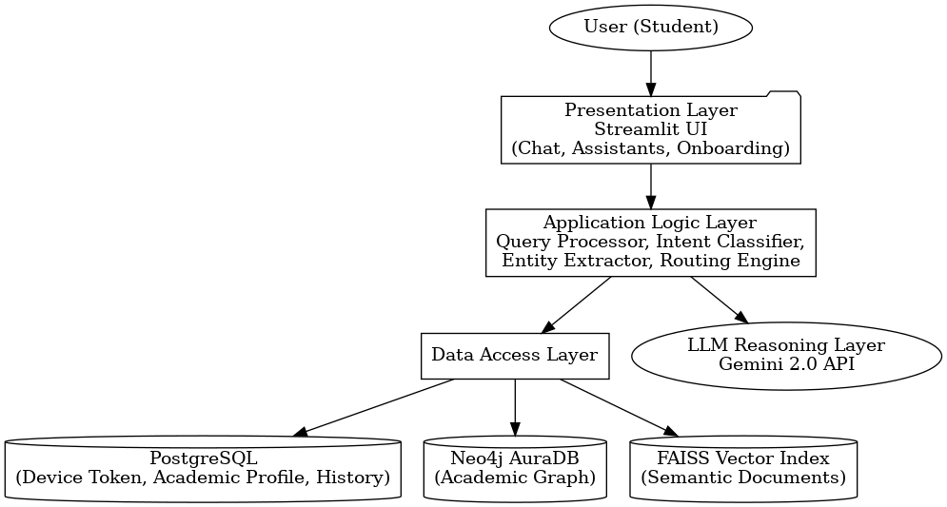
5.2.2 Component architecture
The system is composed of modular components that interact synchronously within the Streamlit runtime.
a) Streamlit UI Layer
- Renders chat interface
- Displays citations and formatted responses
- Shows timetables and exam datasets
- Provides onboarding dropdowns
- Uploads and processes documents
b) Orchestration Layer
- Core pipeline invoked for each query
- Implements the GraphRAG process
- Handles:
- intent classification
- entity extraction
- graph/vector retrieval
- LLM reasoning
- merging and validation
c) Data Layer
- Neo4j AuraDB over Bolt protocol
- FAISS vector index with metadata
- PostgreSQL storing:
- user academic profiles
- query histories
- Device-token identity
d) LLM Layer
- Gemini 2.0 Flash
- Ensures:
- correctness
- grounded answers
- no hallucinations
- safe Cypher generation
Figure: Component diagram
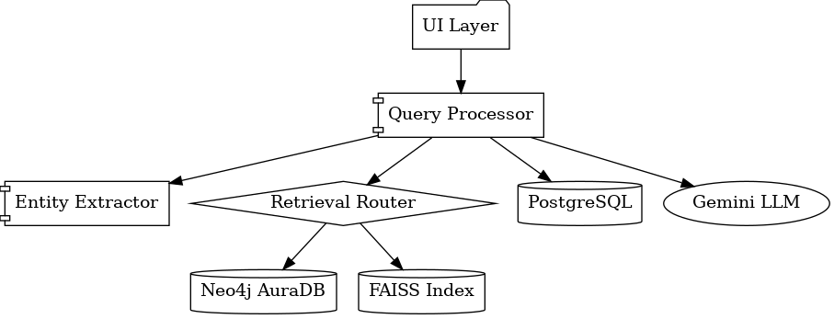

5.2.3 Data flow architecture
Workflow for answering a user query:
1. Browser loads Streamlit application
2. A JavaScript bridge reads the device token
- If missing I will generate new UUID
- Token stored in PostgreSQL + browser
3.Academic Profile Check
- If missing > onboarding form shown
4. User submits a query
5. Intent classification via Gemini
6. Entity extraction (spaCy + regex)
7. Retrieval routing:
- Graph retrieval (Neo4j Cypher)
- Vector retrieval (FAISS)
- Hybrid merging
8. Gemini 2.0 synthesizes grounded output
9. Streamlit updates chat history
10. Query + response stored in PostgreSQL
Figure: Sequence diagram (PNG)
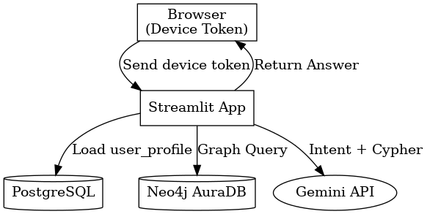

5.3 INTERFACE DESIGN
5.3.1 Academic-only onboarding interface
Collects academic context only:
- Faculty
- Program
- Year of Study
- Semester
Figure: Login wireframe
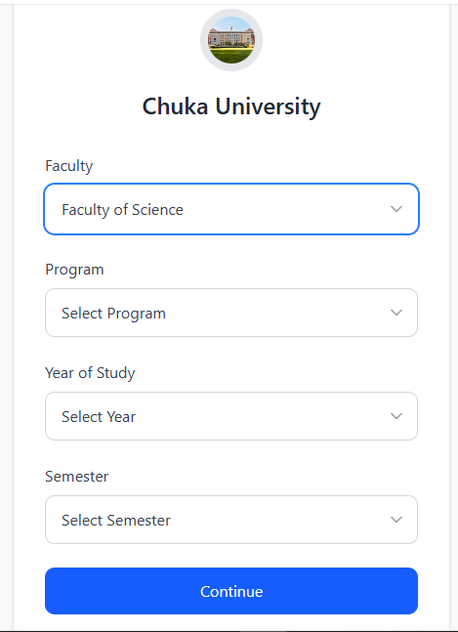

5.3.2 Main assistant interface
After onboarding, the student interacts with a clean, conversational assistant UI featuring:
- Chat panel
- Sidebar assistant tools

- Inline citations and markdown responses
Figure: Main interface wireframe
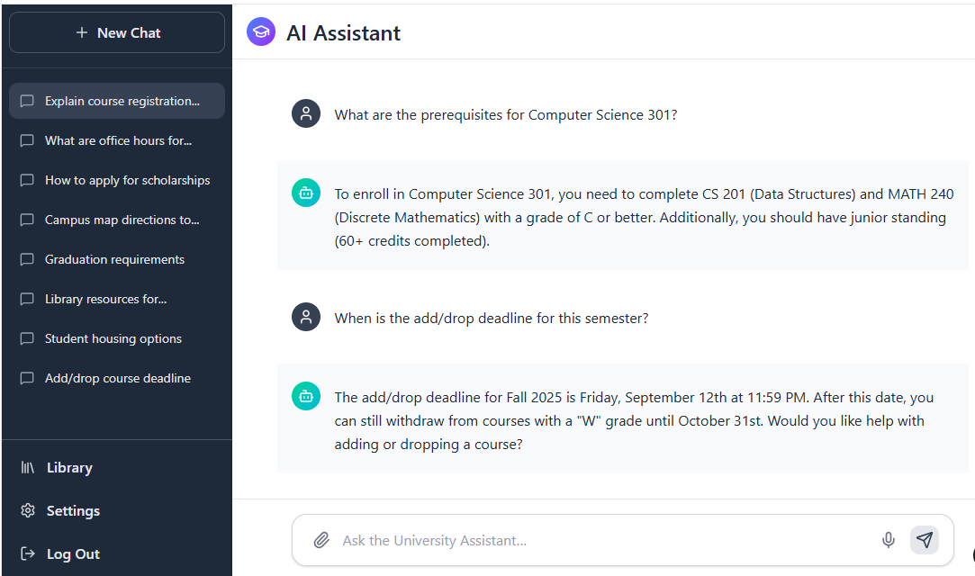

5.4 DATABASE DESIGN
5.4.1 Neo4j AuraDB Knowledge Graph
The graph models Chuka University’s structured academic hierarchy.
Node Labels
- Faculty
- Department
- Program
- Unit
- TimetableSlot
- ExamPaper
- PolicyChunk
Relationships
- (Faculty)-[: FACULTY_HAS_DEPARTMENT]->(Department)
- (Department)-[:DEPARTMENT_OFFERS_PROGRAM]->(Program)
- (Program)-[:PROGRAM_HAS_UNIT]->(Unit)
- (Unit)-[:HAS_TIMESLOT]->(TimetableSlot)
- (Unit)-[:HAS_EXAM]->(ExamPaper)
- (PolicyChunk)-[:REFERENCES_UNIT]->(Unit)
Figure: Database Schema Diagram (Neo4j + PostgreSQL)
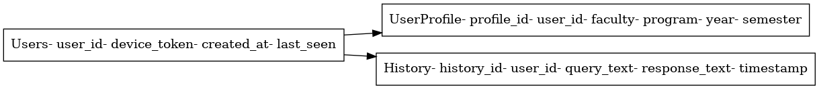
5.4.2 PostgreSQL Schema (Device Token Identity)
PostgreSQL stores persistent lightweight profiles.
1. users
user_id SERIAL PRIMARY KEY
device_token VARCHAR(200) UNIQUE
created_at TIMESTAMP
last_seen TIMESTAMP
2. user_profile
profile_id SERIAL PRIMARY KEY
user_id INTEGER REFERENCES users(user_id)
faculty VARCHAR(120)
program VARCHAR(200)
year_of_study INTEGER
semester INTEGER
updated_at TIMESTAMP
3. history
history_id SERIAL PRIMARY KEY
user_id INTEGER REFERENCES users(user_id)
query_text TEXT
response_text TEXT
timestamp TIMESTAMP

5.5 VECTOR STORE DESIGN (FAISS)
FAISS stores embeddings for semantic retrieval from:
- Student Handbook
- CU Advert
- Policies
- Exam metadata
- Uploaded PDFs
Metadata Fields
- chunk_id
- source
- text_chunk
- page_number
- embedding
Semantic retrieval supports queries like:
- “What is the dress code policy?”
- “How do I appeal an exam?”

5.5 PROCESS FLOW DESIGN
5.5.1 Hybrid GraphRAG retrieval workflow
The hybrid pipeline ensures both accuracy (graph) and contextual completeness (vector search):
- Entity extraction (spaCy / regex)
- Graph neighborhood expansion in Neo4j
- FAISS retrieval of relevant semantic chunks
- Merging structured + unstructured context
- Gemini 2.0 reasoning with grounding
- Streaming response
Figure: Activity diagram (PNG)
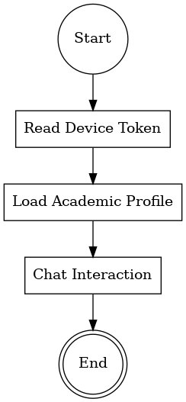

5.5.2 Exam metadata ingestion
Chuka University exam papers are processed using a metadata-first approach:
- Extract exam title, unit code, year, exam date
- Create ExamPaper node in Neo4j
- Store PDF file path in local storage
- Use first-page preview text for FAISS indexing

5.7 SECURITY DESIGN
1. Device Token Identity
- No passwords
- UUID stored in browser
- Linked to PostgreSQL record
- Privacy-compliant
2. Data Protection
- Neo4j AuraDB uses Bolt+TLS encryption
- PostgreSQL secured via credentials in Streamlit secrets
3. LLM Safety
- Cypher query validation
- Strict grounding ensures factual correctness
- Prompts sanitized
4. Document Safety
- Scanning uploaded documents
- Sanitizing PDF text extraction

Figure: Security Architecture Diagram
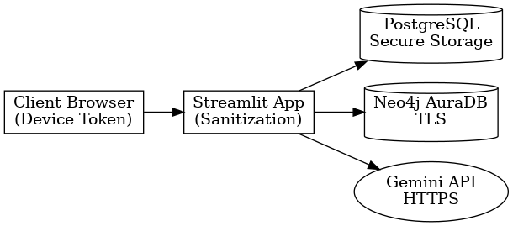

APPENDIX A: RESOURCES REQUIRED / BUDGET
A.1 Hardware Requirements
Item | Quantity | Unit Cost (KES) | Total Cost (KES)
Laptop (Core i5, 8GB RAM) | 1 | Already owned | –
External Storage (Portable SSD) | 1 | 12,000 | 12,000
Smartphone (for testing UI) | 1 | Already owned | -
Hardware Subtotal: 12,000 KES

A.2 Software Requirements
Software / Tool | Type | Cost (KES)
Streamlit | Free | 0
Python (Miniconda) | Free | 0
Neo4j AuraDB Free Tier | Free | 0
PostgreSQL | Free | 0
Jupyter Notebook | Free | 0
Google Gemini 2.0 API | Free Tier | 0
FAISS CPU Library | Free | 0
spaCy NLP Model | Free | 0
PyPDF2 / python-docx / Tesseract OCR/pdfplumber | Free | 0
Software Subtotal: 0 KES

A.3 Internet and Power
Item | Estimated Cost (KES)
Monthly Internet Bundles | 4,500
Electricity | 500
Internet & Electricity Subtotal: 5,000 KES

A.4 Documentation, Printing, and Binding
Item | Cost (KES)
Printing and Binding of Final Report | 200
Photocopying | 900
Documentation Subtotal: 1,100 KES

A.5 Summary Budget
Category | Amount (KES)
Hardware | 12,000
Software | 0
Internet & Electricity | 5,000
Documentation | 1,100
TOTAL ESTIMATED BUDGET: 18,100 KES

APPENDIX B: TIME PLAN (GANTT CHART)
Below is the Gantt chart representing the project timeline from January to March 2025:
Figure: Gantt Chart (January–March Project Timeline)
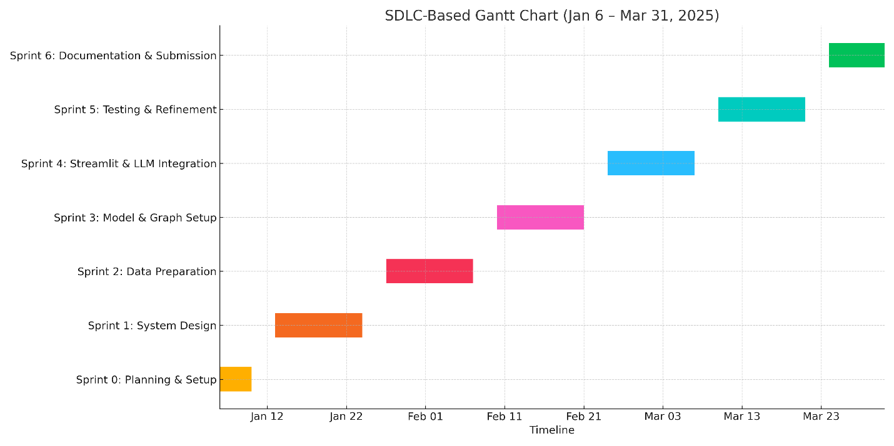

APPENDIX C: SAMPLE QUERIES AND RESPONSES
This appendix provides representative test queries for evaluating system correctness, robustness, and reliability.
C.1 Test Query Set for Evaluation
ID | Query | Expected Response Type | Expected Accuracy
Q1 | What units do I take this semester? | List of units for student's program/year/semester | 100%
Q2 | Show my timetable for Monday | Filtered timetable for Monday only | 100%
Q3 | Find past papers for COSC 482 | List of exam papers with links | 100%
Q4 | How much do I pay per semester? | Fee amount for student's program | 100%
Q5 | What's the exam policy for missed exams? | Policy text from handbook | >80%
Q6 | When is the COSC 482 exam? | Exam date if available | 100% or “Not yet scheduled”
Q7 | What rooms is my class in? | Rooms for student's registered units | 100%
Q8 | How do I defer my studies? | Procedure from student handbook | >80%
Q9 | What happens if I fail a course? | Resit/retake/supplementary policy | >80%
Q10 | Show me units for Year 3 Semester 2 | Units for the specified year and semester | 100%

C.2 Sample Interaction
Student:
“What units do I take this semester?”
System Response:
This semester (Year 4, Semester 1), you are enrolled in the following units:
- COSC 482 — Computer Systems Project 1 (3 Credit Factors)
- ACSC 483 — Software Project 1 (3 Credit Factors)

REFERENCES (APA)
Chuka University. (2024). Student Handbook (August 2024). Chuka University.
Chuka University. (2024). Final Teaching Timetable (Sept–Dec 2025). Chuka University.
Chuka University. (2024). Academic Programs Advert (October 2024). Chuka University.
Google. (2024). Gemini 2.0: Multimodal AI Model Documentation. https://ai.google.dev
Neo4j. (2024). AuraDB Free Tier Documentation. https://neo4j.com/docs
Meta AI. (2023). FAISS: A Library for Efficient Similarity Search. https://github.com/facebookresearch/faiss
Streamlit Inc. (2024). Streamlit Framework Documentation. https://docs.streamlit.io/
spaCy. (2024). Industrial-Strength Natural Language Processing in Python. https://spacy.io/
Reimers, N., & Gurevych, I. (2019). Sentence-BERT: Sentence Embeddings using Siamese BERT Networks. EMNLP.
Python Software Foundation. (2024). Python 3.11 Documentation. https://www.python.org/doc/
PyPDF2 Developers. (2024). PyPDF2 Documentation. https://pypdf2.readthedocs.io/
Blackford, R. (2023). Tesseract OCR Documentation. https://tesseract-ocr.github.io/
PostgreSQL Global Development Group. (2024). PostgreSQL Documentation. https://www.postgresql.org/docs/
OpenAI. (2023). Retrieval-Augmented Generation (RAG) Overview. https://platform.openai.com/docs

